We consider the Auto.csv dataset that we have used in assignment 3. In this problem, we are interested in predicting the variable mpg = the recorded miles per gallon of the auto based on all the available independent variables which are listed below.
Cylinders = Number of cylinders between 4 and 8
Displacement = Engine displacement (cu. inches)
Horsepower = Engine horsepower
Weight = Vehicle weight (lbs.)
Acceleration = Time to accelerate from 0 to 60 mph (sec.)
Try to evaluate the models (model 1-5) that you constructed in assignment 3 following the steps below, and you are expected to write an analysis report which contains all the results from these steps.
-------------------------------------------------------------------------------------------------------------------------
Assignment 4
Analysis Report
1. Compare all the regression models that you constructed in assignment 3 by creating a comparison table with metrics: adjusted R-square, AIC, and BIC. What can you learn? Can we suggest the best model based on these metrics? Why?
Step 1: Construct a comparison table
Based on the assignment 3, we have the following OLS results for each model.
Model 1 Model 2
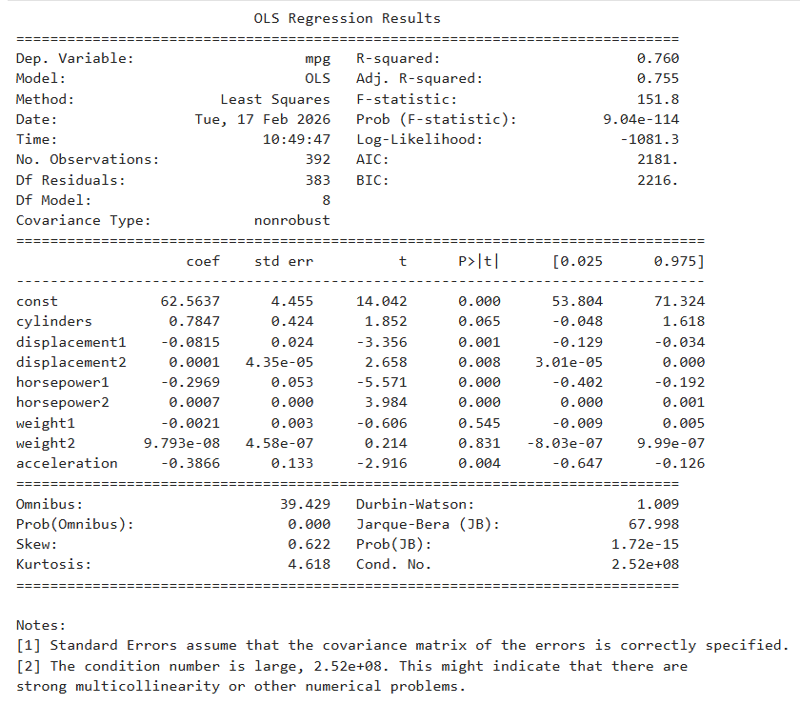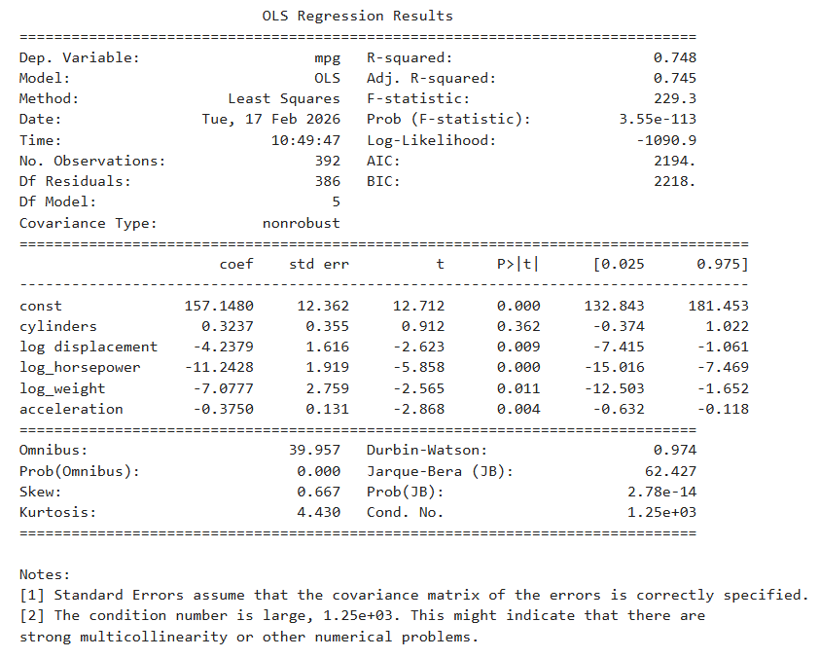

Model 3 Model 4
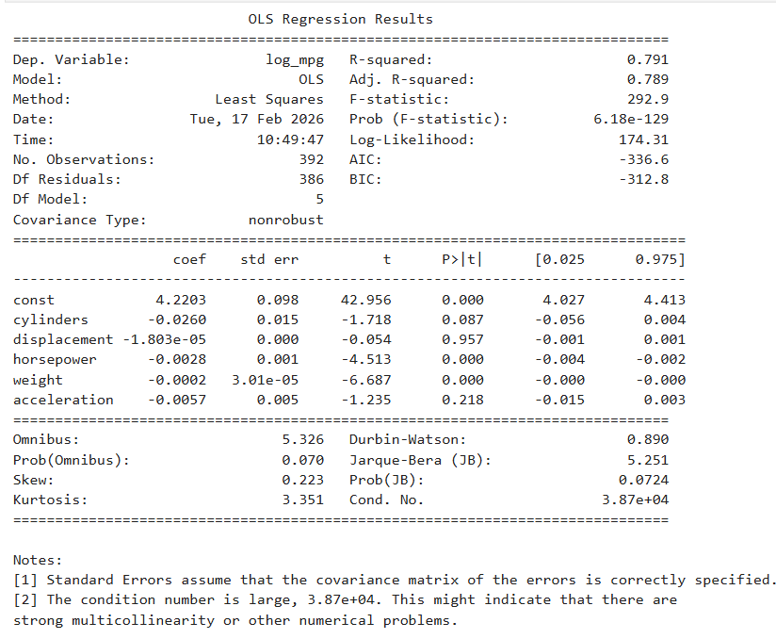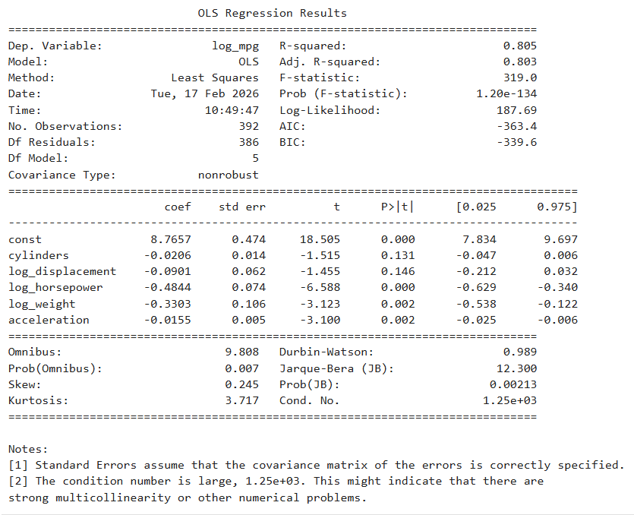

Model 5
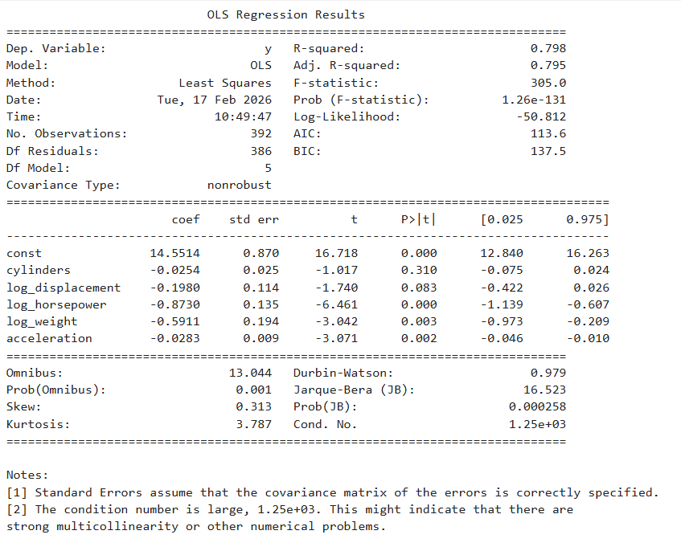
 | Model 1 | Model 2 | Model 3 | Model 4 | Model 5
Adjusted R-squared | 0.755 | 0.745 | 0.789 | 0.803 | 0.795
AIC | 2181 | 2194 | -336.6 | -363.4 | 113.6
BIC | 2216 | 2218 | -312.8 | -339.6 | 137.5

Step 2: Comparing the result
Among the 5 models, Model 4 performs best based on those metric indicators.
It has the highest adjust R-squared (0.803), indicating the strongest explanatory power after transforming for the model complexity. It also has the lowest AIC (-363.4) and BIC (-339.6), suggesting it balances best between the likelihood of the model (goodness of fit) and the number of parameters (model complexity).
However, we can easily notice that the AIC and BIC of Model 1 & 2 (around 2200) have different range value than Model 3 & 4 (around -330 to -365), leading to the cause of variety in response transformations. Since Model 3 & 4 use the log transformation on the response value. In general, even with comparable groups, the Model 4 is still the best transformation model.
After the comparison, we learnt that:
- The transformation of the response value improves the model significantly.
- The combination of log response and log predictors (Model 4) gives the strongest performance.
- Box-Cox (Model 5) does not outperform simple log transformation.
According to the assignment 3, Model 4 also satisfies most of the regressions assumptions and has significantly interpretable predictors, contributing to the conclusion about the best performance model.

2. Use training-testing validation to evaluate the performance of the models. Specifically, randomly split the data into 80% training and 20% validation sample. Build the linear regression models with different model correction strategies that we used in assignment 3 using training sample, and predict on the validation set. Then assess the prediction accuracy. Repeat the entire procedure (data splitting, model construction, validation set prediction) 100 times. Report the average prediction mean squared error for each model. What can you learn from these results?
Step 1: Construct a dataframe for all models
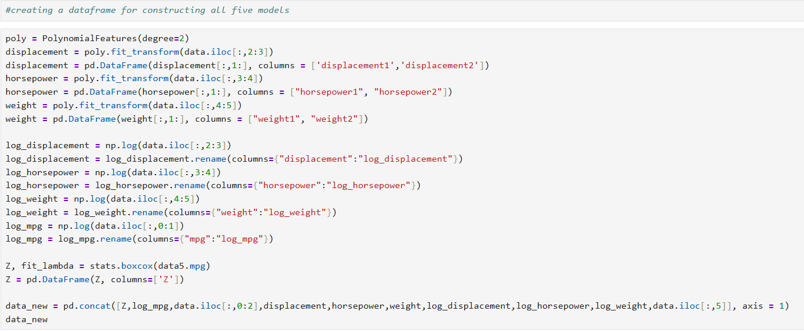
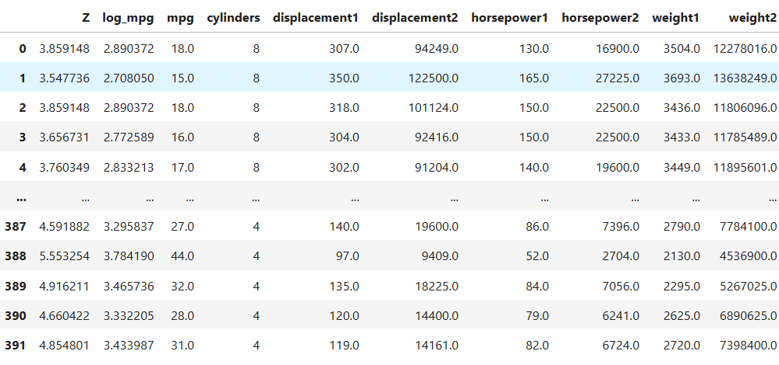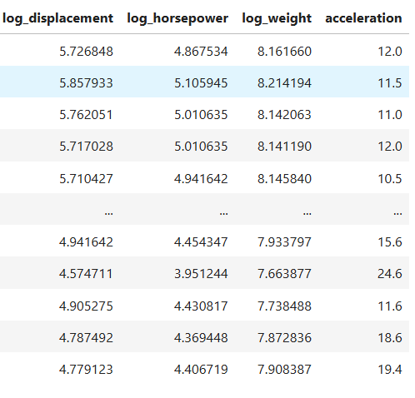
Step 2: Build the linear regression models with different model correction strategies, using the training data to predict on the validation set. Repeat the process 100.
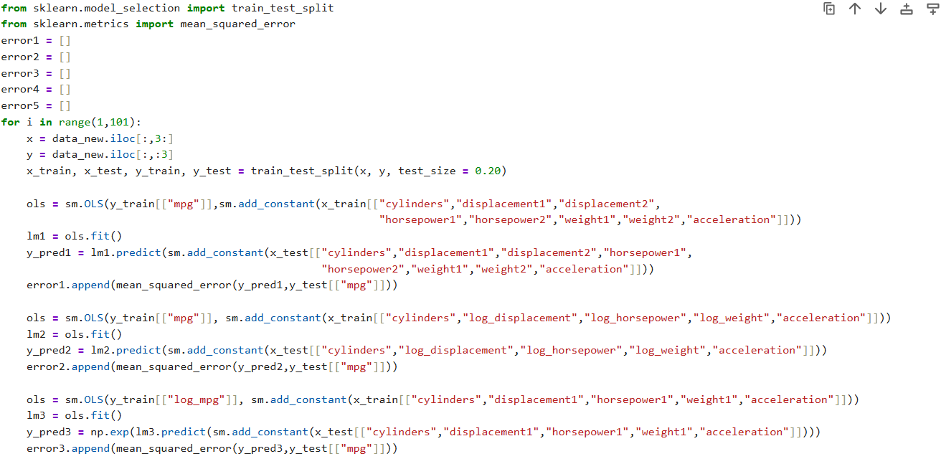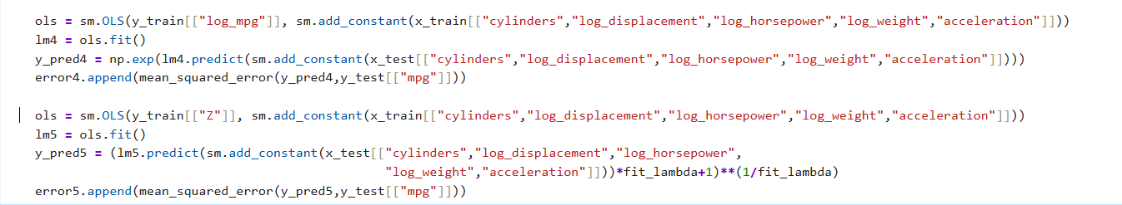
Step 3: Calculate mean of each error set and display
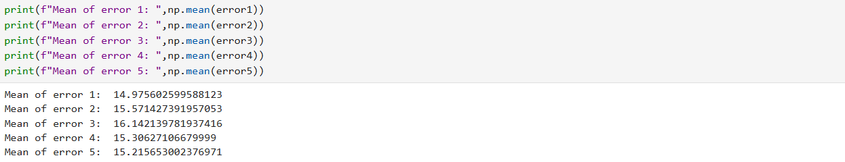
Step 4: Conclusion
Based on this result, the model one has the lowest mean squared error (14.98), suggesting it is slightly better in performing prediction on the unseen data. However, the difference between MSE score is very small which can indicate that all the model can predict the unseen data similarly.

3. Use 10-fold cross validation to evaluate the performance of the models. Report the average cross validation error for each model. What can you learn from these results?
Step 1: Construct 10-fold cross validation of the models
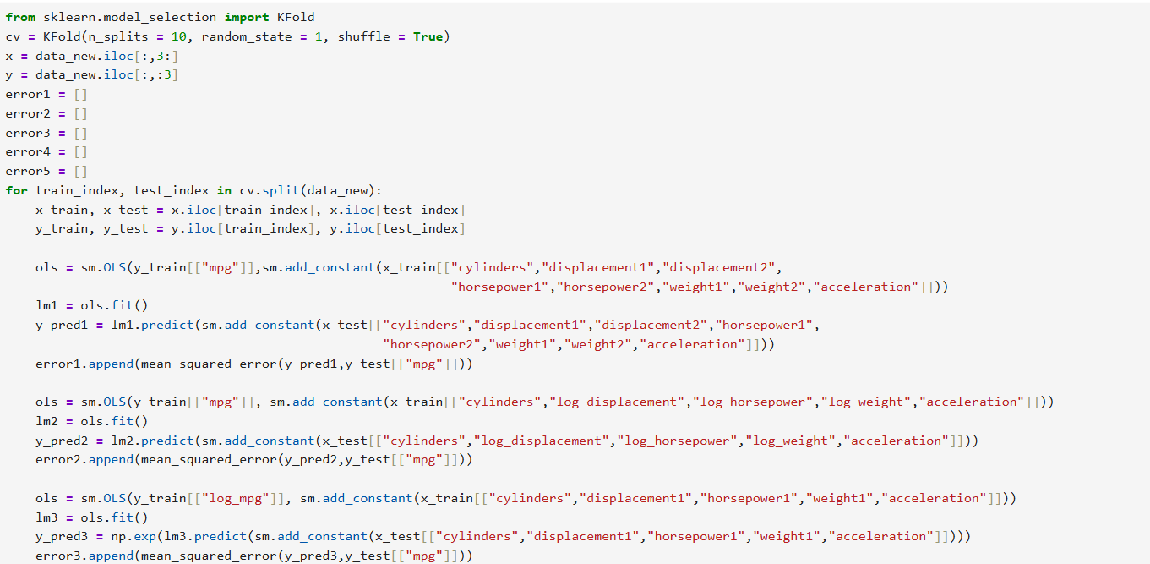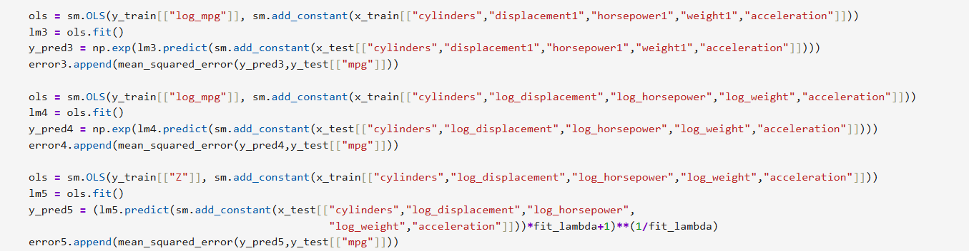
Step 2: Calculate mean of each error set and display
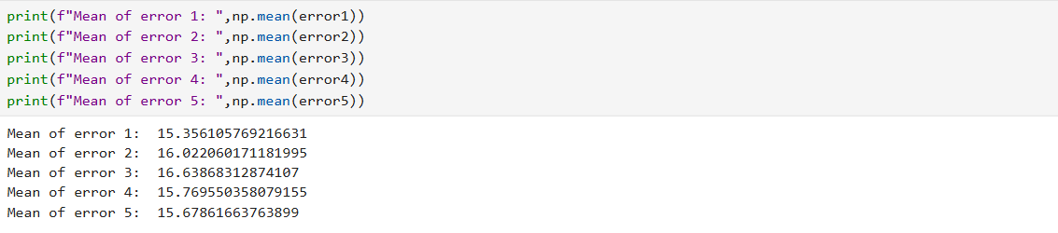
Step 3: Conclusion
Based on the mean values of each model, the Model 1 has the lowest mean squared value (15.35), which indicates the model 1 performs on predicting validation data best compared to other models. However, the difference in cross-validation error across models are relatively small. Therefore, we can suggest that all the models predict similarly.

